`



SCSJ 1023: Technique Programming II

Assignment 1 : Exercise 2

|  |  |
| --- | --- |
| NAME | MATRIX NO |
| AHMAD SYAFIQ BIN ANUAR | SX160093CSJS04 |

Exercise 2

1. Code evaluate.cpp :

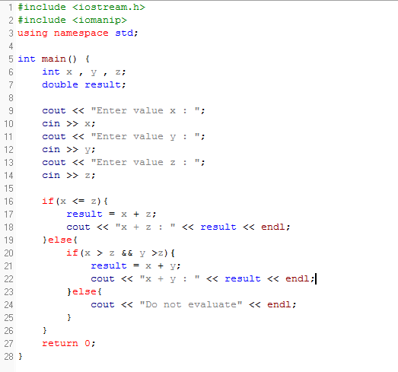

Output:

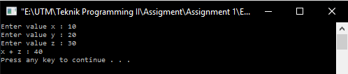

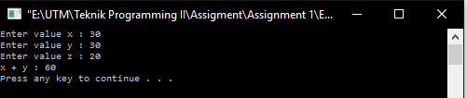

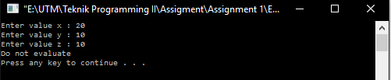

1. Code level.cpp :

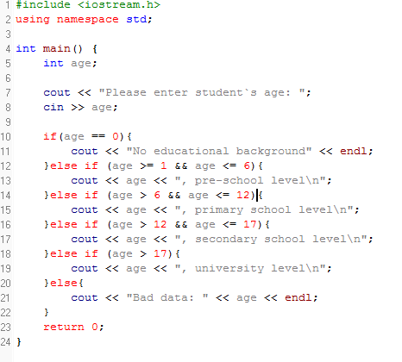

Output:

